Tutorial #1 Moving left and right in a 2D space.

**Setting up the scene**For this tutorial we’ll be working in Unity 2D, so first things first go into the Unity Hub and open up a brand new Unity 2D project.

Once The project window opens you should be able to see a blank canvas, now that’s because we have a brand-new scene with no objects implemented at the moment.  
  
First things First, if we want to make a scene that allows for us to make 2D movement a reality then we need to make a platform, something very simple and a character. For this particular tutorial, I used a simple White Rectangle as the ground. In order to do that go into the hierarchy (Left of the screen) and right click>2D Object>Sprite>Square. A screenshot of a computer

Next add a box collider 2D component to it, this ensures we have a solid platform. To do this select the Square sprite, and go click “Add Component”, type Box Collider 2D and this gives us a solid surface for our characters to move on.   
  
**Setting up Character Movement**  
Now we have a stage, all we need now is a player object do the same thing and make a cube and now let’s make a new script. Call this one “Character movement”. Make sure to add a box collider the same way we did it earlier for the Ground sprite.

Double click on the script that was just made just to open it. First things first we need to declare some variables. Type the following in. 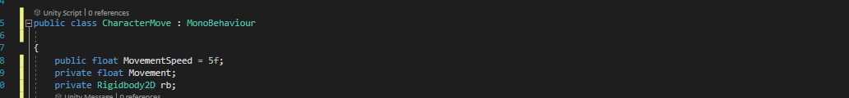

Remember to add a Rigidbody2D component the same way we did previously with the Box Collider.   
  
Next let’s focus on working the final parts of the code.  
  
Here we’re calling our Rigidbody function and having our script tell unity to identify the object with a Rigidbody 2D component. The “Movement=Input.GetAxis(“Horizontal”); line helps us to the program to move on a horizontal axis. In Unity’s registry it defaults any movement to using the WASD keys so using A moves us to the left and the D key to the right.   
  
The final Line, rb.velocity=new Vector2(Movement*MovementSpeed,rb.velocity.y); calls on the movement functionality from before and tells Unity to use this line to dictate the “Movement Speed component.

Once done, your script should look something like this.   
  
**Testing our character Movement**

Next, let’s test our movement to see if it works but how do we do that? Well before we close our script be sure to save the script, next let’s move back to Unity. You should see your new script in your assets folder and your character Movement script. Next choose the Square object that you made your player.

Next navigate to the Assets folder and drag and drop your script into the Square’s inspector, soon you should be seeing this on your inspector.

Hear you can now change the Movement speed, for this test we’ll be keeping the speed of our movement at 5 a relatively fast speed, you can choose to change this if you feel. Now if we press the play button, and use the A and D keys or the left and right arrow keys to move around our character will slowly but surely be able to move in a 2D space!   
 